Activity Worksheet: Drinking rules

Introduction:
Our brain is strongly influenced by hydration status. Staying hydrated is important for feeling energized and for proper brain performance. Drinking too little, can cause cognitive impairment, loss of concentration, tiredness and headaches. Therefore, drinking is especially important in school!
Elementary school children should drink 1 to 1 ½ liters of water per day. That's 2-3 cups or 1 bottle of water alone in the morning.
But many children forget about it. What could remind you to drink enough water at school?

Target group: primary school
Learning goals: drink enough at school
Time needed: 15 minutes/1 schoolyear

Material needed:
- poster

What to do:
- Set and record drinking rules
Rules and rituals help to remind you to drinking at school.
Especially in elementary school, the introduction of drinking rules has been proven.
- Write your class drinking rules on a poster and hang it in a visible place.
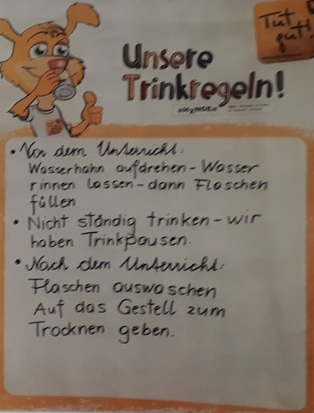
Ideas for drinking rules:
- I only drink tapwater at school / in class!
- In the morning before lessons start I fill my water bottle with fresh water!
- I finish the bottle until noon.
- If I want to concentrate especially (e.g. for tests), I drink water before.
- After gymnastics, sports, the teacher reminds us to drink.
- ....

